**Used Cars Dataset**

BUAN 6337

Predictive Analytics Using SAS

**Table of Contents**

Executive Summary 3

Introduction 3

Data Description 3

Pre-processing 4

Exploratory Data Analysis 5

Predictive Models 8

General Linear Model 8

Random Forest 14

Conclusion 19

SAS Code 19

Appendix 26

Appendix A – Resources 26

Appendix B – Non-essential Graphs 26

Executive Summary

The second-hand car market has been a popular choice for Americans when it comes to purchasing cars. In this paper, we analyzed how certain factors and conditions of a second-hand car would affect its price. For this analysis, we used predictive analytics techniques namely linear regression and random forest to identify important features required to accurately predict the price of used cars. The dataset contained information on used cars from 1985 through 2019.

Introduction

Craglist.org collected the price and different specs of the used cars. This dataset can help future customers in several ways:

(1.) identify which brands are the most popular choices from historical information;

(2.) use the data as a reference to consider whether the price of a targeted second-hand car is reasonable;

(3.) create the model to help potential buyers and sellers determine the price of the cars

This can also help customers with no knowledge in cars gain an overview of the second-hand cars market.

Data Description

The used car dataset contains data gathered from Craglist.org and has more than 500,000 records between 1985 through 2019. The dataset includes information on 25 unique variables, including years, manufacturers, and models, conditions, etc.

Table 1

|  |  |
| --- | --- |
| **Variable** | **Definition** |
| ID | Data entry ID |
| URL | Website URL containing the vehicle details (unique identifier) |
| Region | Craigslist region |
| Region_url | Region URL |
| Price | Data entry price |
| Year | Data entry year |
| Manufacturer | Vehicle manufacturer |
| Model | Vehicle model |
| Condition | Vehicle condition |
| Cylinders | Numbers of cylinders |
| Fuel | Fuel type, gas or diesel or others |
| Odometer | Miles traveled by vehicle |
| Title_status | Status of vehicle, clean or rebuilt or others |
| Transmission | Transmission of vehicle, automatic or manual or other |
| Vin | Vehicle identification number (unique number) |
| Drive | Type of drive, 4wd or null or others |
| Size | Size of the vehicle, full-size or null or others |
| Type | Generic type of vehicle, SUV, pickup and etc. |
| Paint_color | Color of the car |
| Image_url | Image URL containing the vehicle images (unique identifier) |
| Description | Listing description |
| County | County of listing |
| State | Listing State |
| Lat | Latitude of listing |
| long | Longitude of listing |

Pre-processing

A number of variables in the databases had a large number of incomplete and missing information, text, images and urls. These variables cannot be effectively utilized in the prediction models. Therefore, we removed 10 variables viz - id, URL, VIN number, size, image_url, region_url, description, county, latitude and longitude. We removed the null/missing values from the dataset.

The three numerical variables, which are year, price and odometer were highly skewed. In order to get a higher prediction accuracy and prevent bias in the models, we analyzed the descriptive statistics of these variables to identify outliers. Based on our analysis, there were few observations in the range of data that we dropped. For the variable age, we dropped all observations older than 1985. For the variable price, we dropped all observations less than $500 and greater than $70,000. Finally, for the variable Odometer, we dropped all observations less than 100 miles and greater than 300,000 miles. All the observations that we dropped were outliers observed form the descriptive statistics of each of these variables as seen in ***Appendix B. Figure -1*** represents the variables before preprocessing and ***Figure -2*** represents the 3 variables after following the above data cleaning steps. After dropping all these outliers, we dropped any special characters of the existed variables to boost the accuracy of our models. After all the data prepossessing, we have a total of around 125000 observations.

Exploratory Data Analysis

The below plot shows four of the most representative categorical variables of used cars, which are condition, cars’ type, paint color, and drive mode (front-wheel, back-wheel or all-wheel). The plots were sorted by percentages by variables. As can be seen below, the highest percentages of used cars’ type on craigslit were filed in SUV, sedan, and truck. And also, the highest percentages of used cars’ paint colors are white, black and silver.

Figure 1

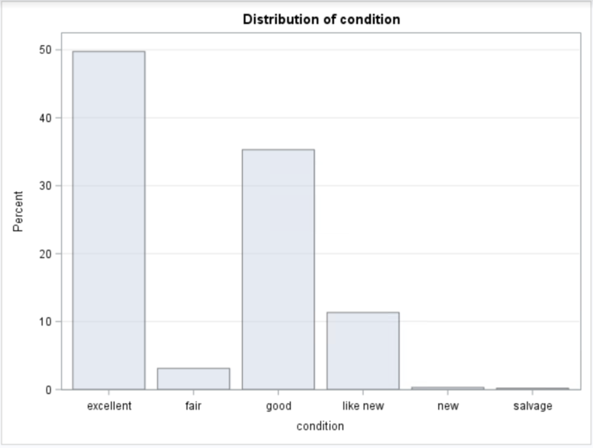

Figure 2

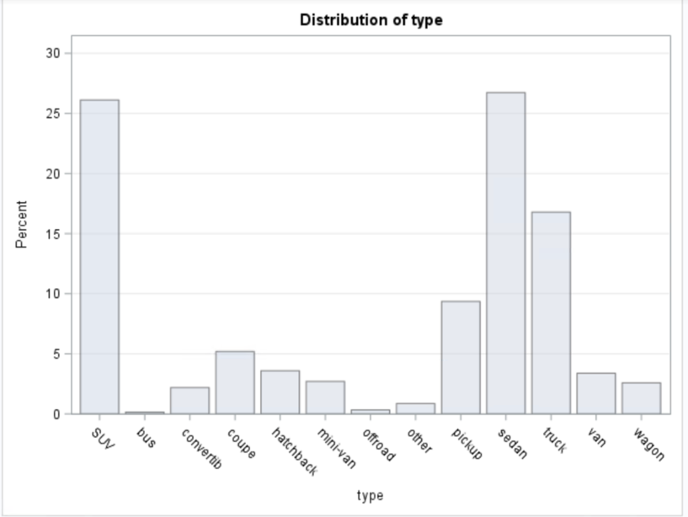

Figure 3

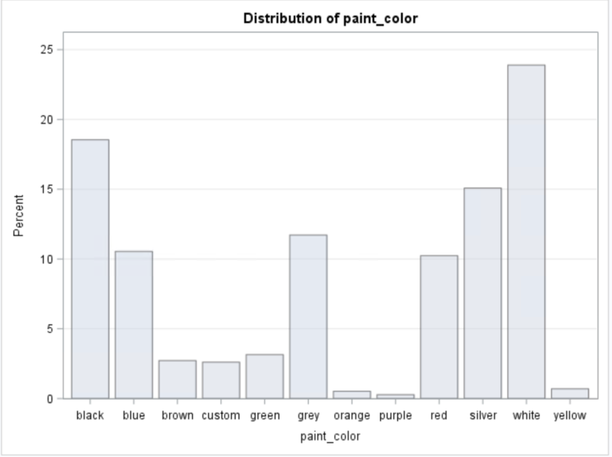

Figure 4

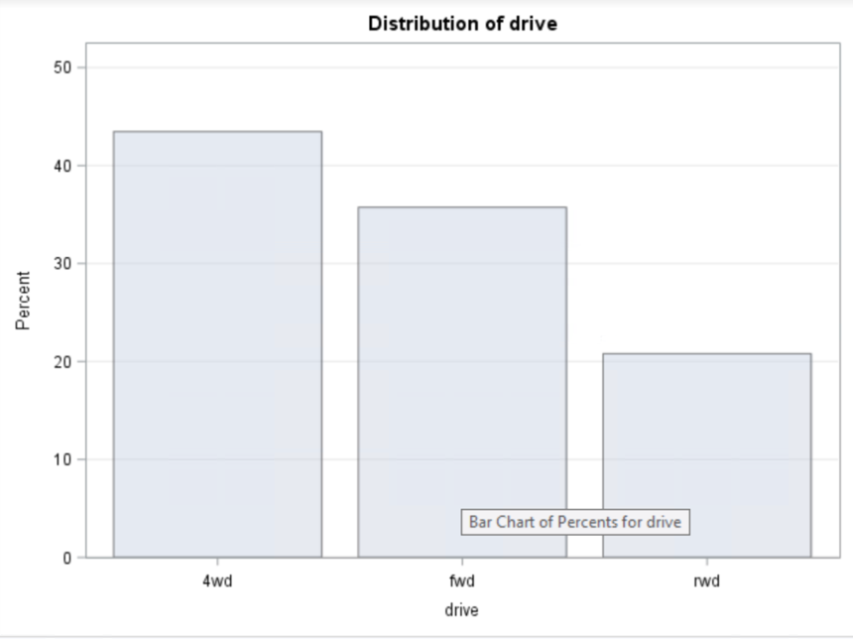

After removing outliers from three numerical variables, each variable is closer to standard distribution. Distribution of year is right skewed, and distribution of price is slightly left-skewed. From the “Correlation Coefficients” Table, we can see that the year of car has positive correlation with price, and odometer has negative correlation with price.

Figure 5

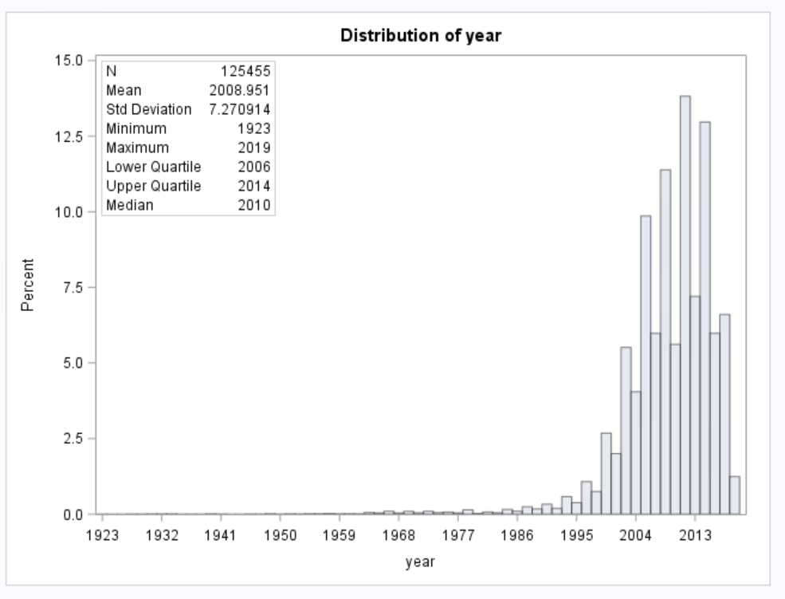

Figure 6

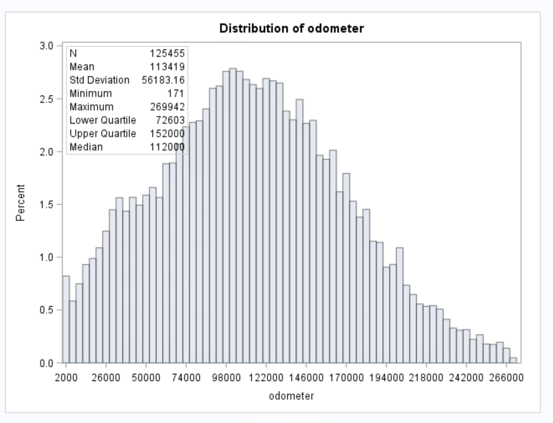

Figure 7

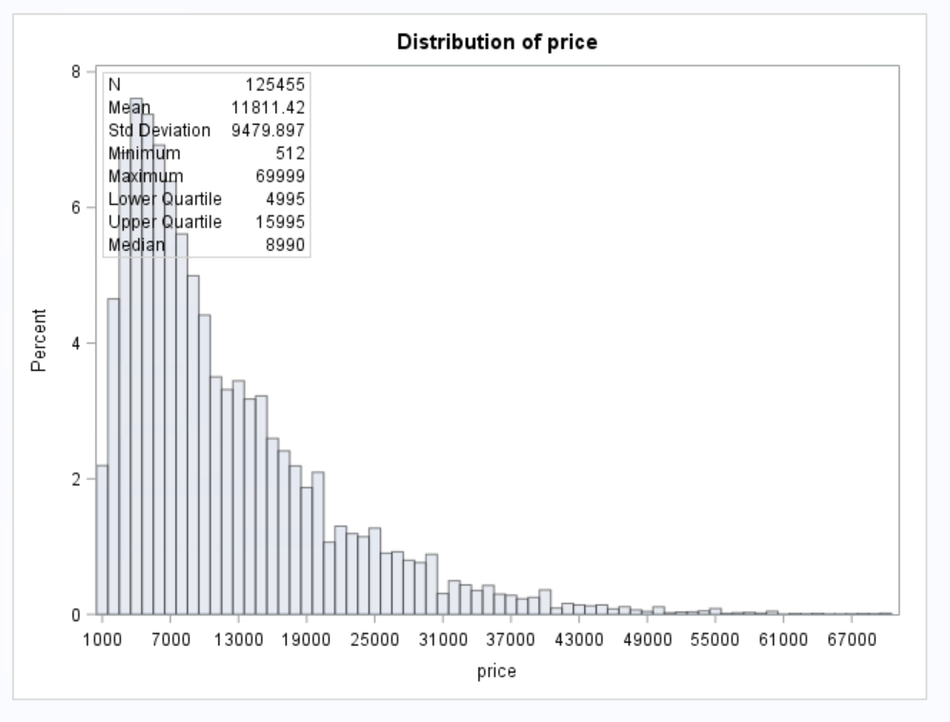

Figure 8

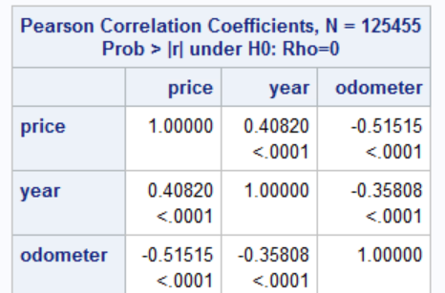

Predictive Models

## 

## General Linear Model

The first model that we used to predict the prices of used cars is the linear regression model. We used the SAS procedure glmselect as the dataset contains categorical features that are useful in predicting the price of used cars. The variables price and age were skewed even after the data prepossessing process. In order to make the distribution of these two variables conform to normality and enhance the performance of the Linear regression model, we performed a log transformation on price and age ***Appendix B – Figure3.***

The dataset has a lot of categorical variables, but the variables title_status, condition, transmission, cylinders and drive had classes which directly affect price in a positive or negative way. For example, if we consider the variable condition, a car listed as “like new” is more expensive than salvage. As the categories in these variables (title_status, condition, transmission, cylinders and drive) are ordinal in, we used label encoding for each of the categories.

After performing the additional data manipulation steps, we performed a linear regression on the log of price using og_age odometer condition_wt cylinders_wt drive_wt fuel manufacturer paint_color title_wt transmission_wt type.

Figure 9

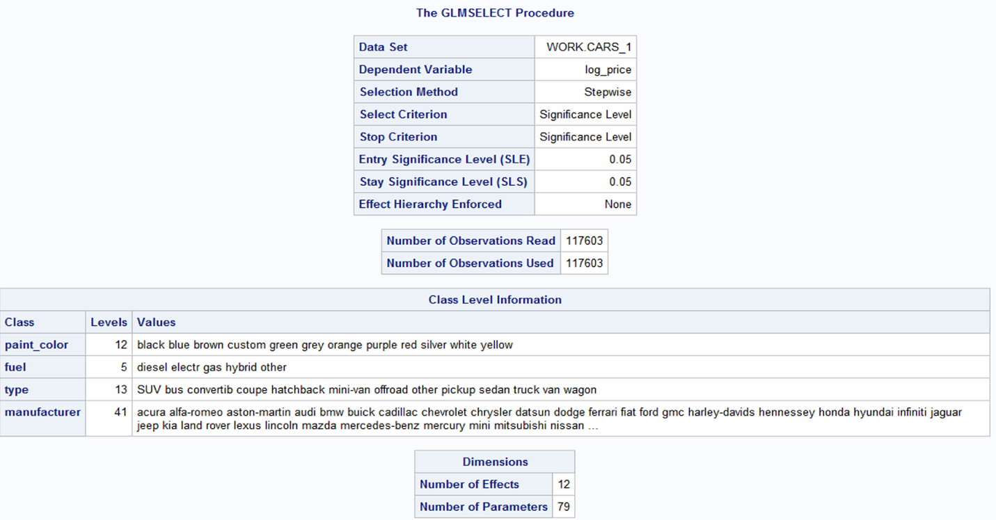

We ran the glmselect model using the default stepwise selection criteria which works on one feature at a time. This criteria evaluates each feature at every step based on the defined significance level to pull in a new feature after evaluating its significance level in the model. It also evaluates the change significance level of existing features when a new feature is added. In this way, it gives us a lean, accurate and significant list of features in the final step of the model.

We can see from the image above that the significance level for a feature to enter the model and stay in the model has been set to 0.05.

The model also displays needle charts ***Appendix B – Figure 4*** of all features at the end of every step, these charts are a visual representation of the remaining variables ranked on the significance and the order in which they enter the model.

Figure 10

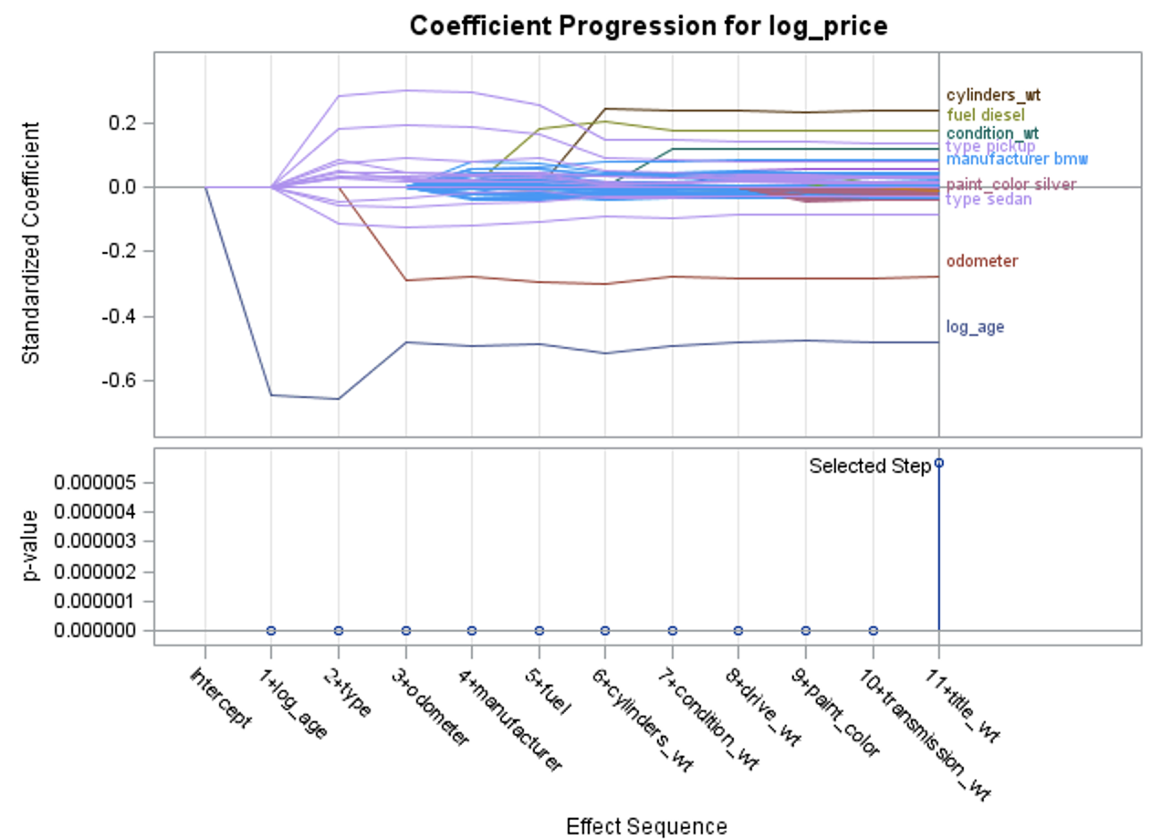

PROC GLMSELECT also displays a panel of two plots that show how the standardized coefficients and the criterion were used to choose the final model that evolved as the selection progressed. We can discern from the plot that odometer and age have a negative effect on price. This can be interpreted as the price of a car will be lower if it has racked up more miles and if it is old. The plot also shows the variables ordered by when they entered the model, in this case, we see that log_age entered the model 1st with a standardized coefficient less than -0.06 but as more variables were added at subsequent steps, it’s value increased. This graph keeps a running track of the standardized coefficients, and you can see when they start to stabilize.

Figure 11

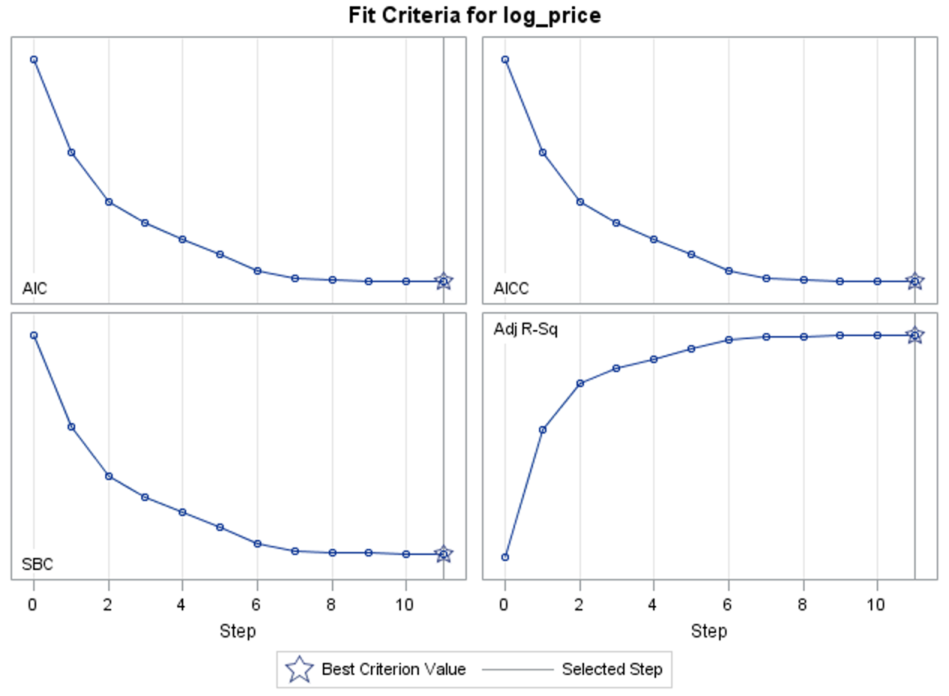

The fit criteria panel lists values for a default set of fit criteria, AIC, SBC, AICC, and adjusted R-square. The star denotes the best model of the eleven that were tested in this model. The model at Step 11 has the best AIC, AICC, SBC and adjusted R-square.

Figure 12

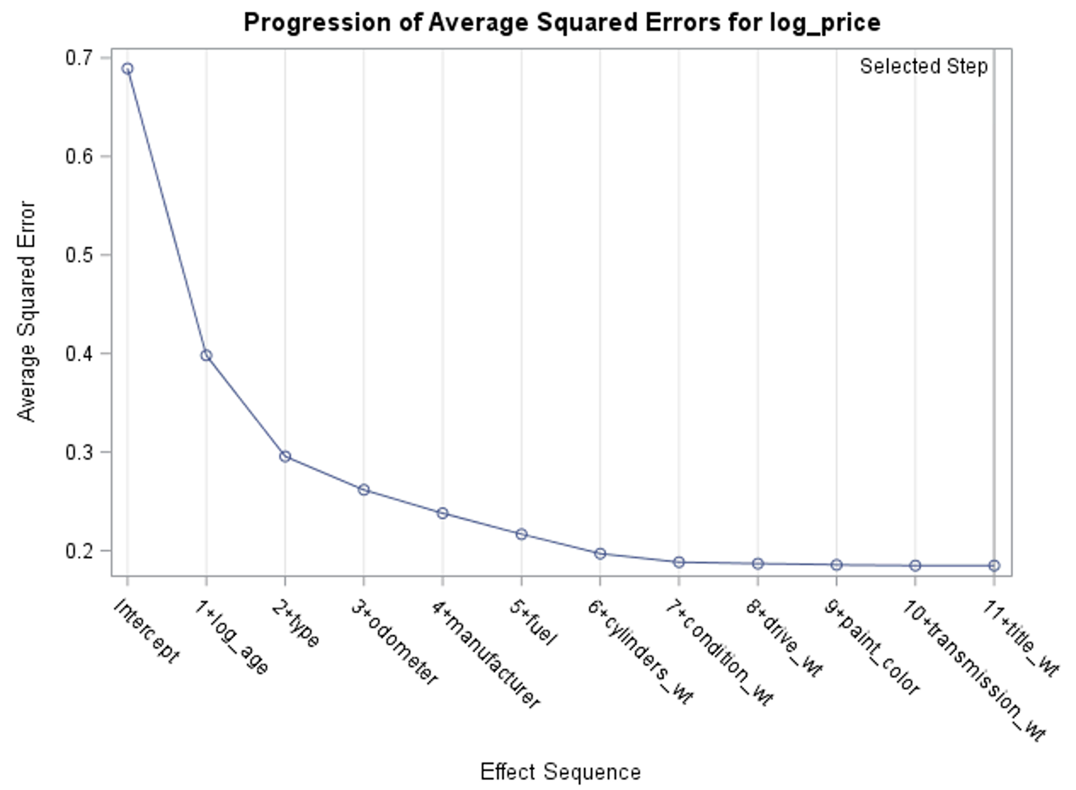

The Progression of Average Squared Errors plot shows the average squared error (ASE) evaluated for the model that was chosen at each step. Average squared error is similar to mean squared error, but it uses a different denominator in its calculation. As more effects are added to the model, the ASE decreases. There is less unexplained variation in log_price. This model shows small differences in unexplained variations between the models at steps 7,8,9,10 & 11 which means that  if you chose to use the model at Step 7,8,9 or even 10, you could do so with little loss of explanatory power.

Figure 13

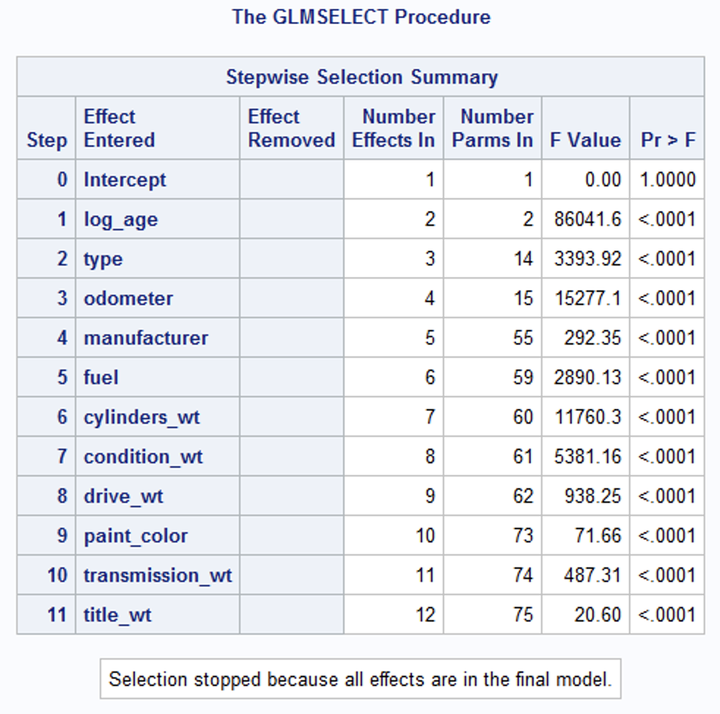

The selection summary shown above tells us about all the variables that are included in the model along with their significance level, all 11 variables considered in the model were found to be significant and were included in the model.

Stepwise selection efficiently searched through all of the possible models using significance level as the criterion for variable selection, and suggested a model using all 11 of the potential predictors.

Figure 14

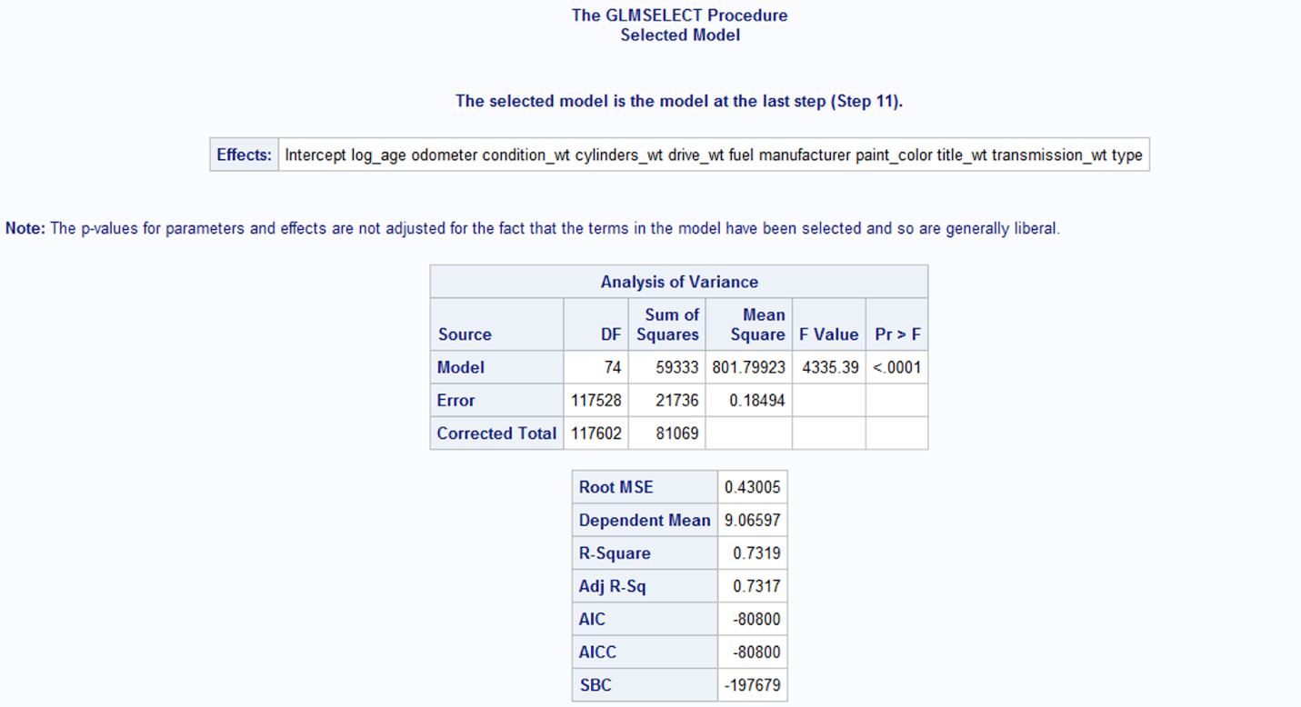

The recommended model includes all predictors required to accurately predict the price of a car ***Appendix B – Figure5***. Model fit plots compared the models at each step of the stepwise process, including the intercept-only model. The R-squared value measures the proportion of the variation in your dependent variable (log_price) explained by the independent variables for a linear regression model. The adjusted R-squared penalises the addition of variables in the model. It has the highest adjusted R-square (0.7313) and optimal values of AIC, AICC and SBC.

**Result:**

The p value of the model is <0.0001 which means that the model is significant even at 99%.

The RMSE of the model is 0.043 low (low error) and the adjusted R-squared value is 0.73.

Therefore, we can conclude that the independent variables in this model reliably predict the dependent variable log_price.

## 

## Random Forest

1. Data Manipulation

To better utilize the computation of the random forest model, we need to convert the numerical variables in our data set to categorial variables. Therefore, we need to creates intervals for price, year and odometer variable. Intervals were established based on the distribution of each variable. We create 6 intervals for both price and odometer, and 7 intervals for year.

1. Random Forest Model

First, from “Model Information” Table below, we can understand few default settings for the model. There are 4 variables that were randomly selected to test each node in each tree. Also, the maximum number of trees were 100. “In Bag Fraction” was set at 60% which is the default, making the OBB (Out-of-bag) at a rate of 40%. Also, the “Prune Fraction” is defaulted at “0″, therefore this model is not to prune the decision trees.

Figure 15

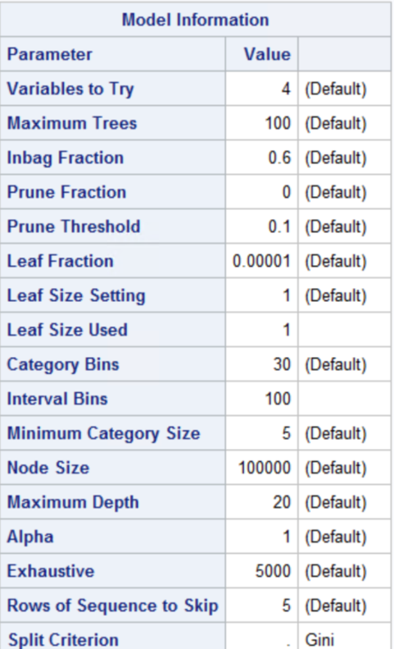



Next, from table “Baseline Fit Statistics”. We can conclude that the model identified a 58% of miss-classification. It also means a rate of 42% of accurate classification. This indicated that the majority of the sample has been classified correctly in each of the randomly selected samples. Due to we have a relative large data set, we used 125,455 observations in the model.

Figure 16

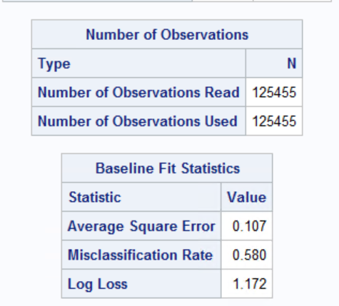

When analyzing the fitness of the forest, we utilize the “Fit Statistics” table. From the table below, it shows the misclassification rate of both train/OOB sets has reached its lowest point with the tree number 100. The misclassification rate for OOB data set is 17.4%, which means it has accurate classification rate of 82.6%. Higher the accurate classification rate, the higher accuracy of the predicated model.

As the number of trees increasing, the misclassification rates tend to decrease and ASE (Average Square Error) tends to decrease as well **(Appendix B – Figure – 6).**

Figure 17

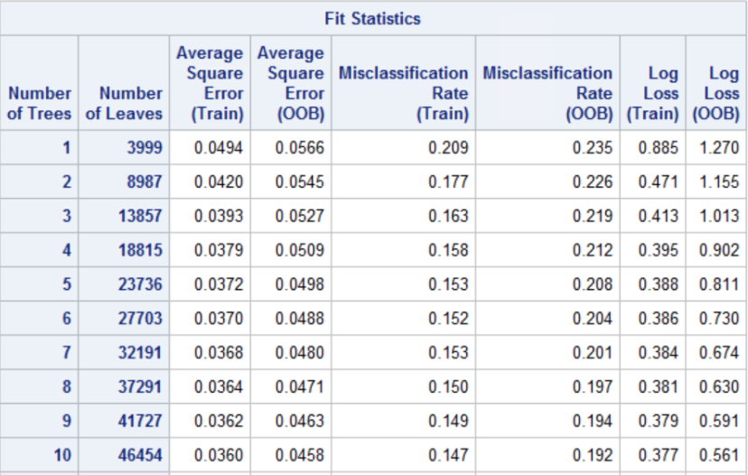

Figure 18

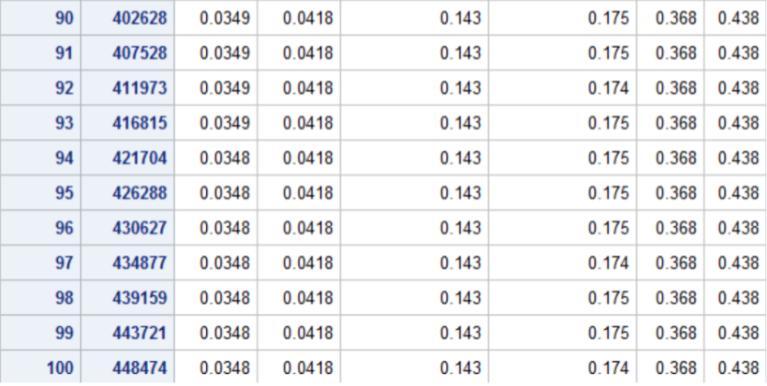

Finally, “Loss Reduction Variable Importance” Table indicated each variable’s importance sort by the contributes to the predictability of this random forest model. The year of the car, odometer and type has the most contribution to accuracy of the predictive model. The variables are listed as highest importance to lowest importance in terms of predictive model.

Figure 19

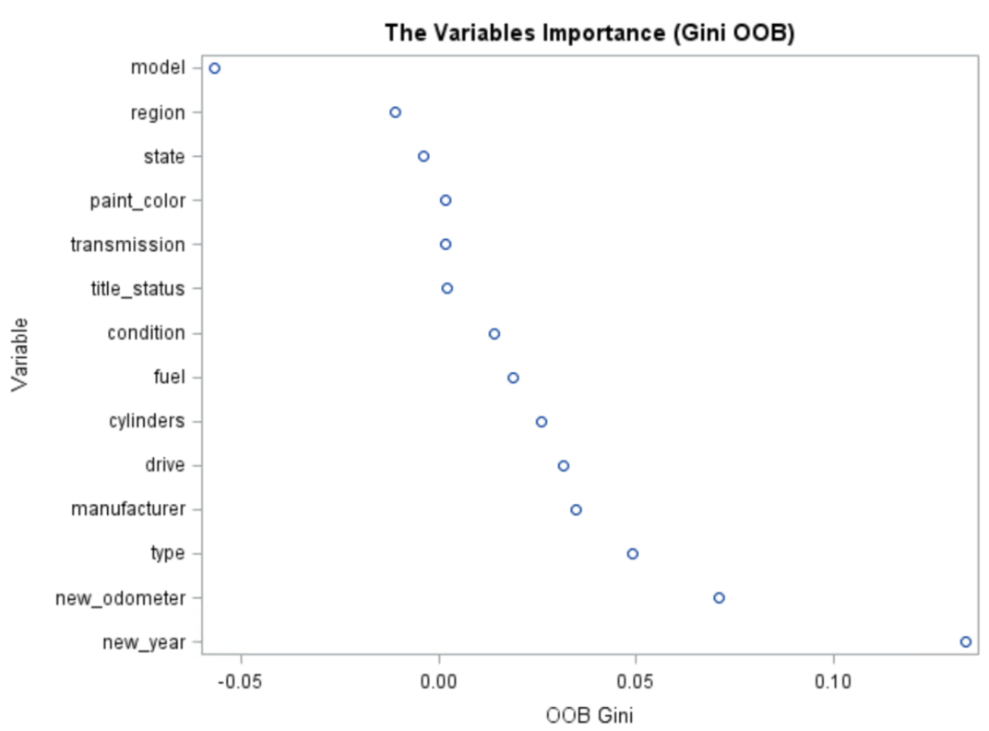

Figure 20

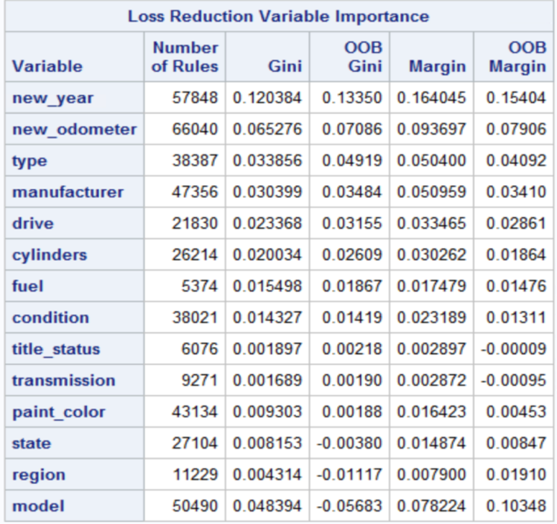

Conclusion

We can conclude that the variables that are more likely to be a good fit in a model to predict a used car’s price is the year of the car, odometer and type of the car.

SAS Code

***************

* Group Project: BUAN/MKT 6337

* Group 2

* Dataset: Group project

***************;

**Pre-processing**

dm 'clear log';dm 'clear output';

libname project "E:\Users\JXT190011\Documents\My SAS Files\9.4\project";

title;

proc import out= work.vehicles

            datafile= "E:\Users\JXT190011\Documents\My SAS Files\9.4\project\vehicles_clean.csv"

            dbms=csv replace;

     getnames = yes;

     datarow=2;

run;

/*dropping the variables id url vin size image_url region_url description county lat long*/

data work.vehicles(drop = id url vin size image_url region_url description county lat long);

set work.vehicles;

run;

/* removing outliers from price, odometer & year*/

proc sql;

create table cars as

select*

from work.vehicles

where (price > 500 and price < 70000)

and (odometer > 170 and odometer < 270000)

and (year > =1985 and year < 2020);

quit;

/* data cleanup and removal of special characters from the dataset*/

data cars;

set cars;

model=compress(model, '0123456789abcdefghijklmnopqrstuvwxyzABCDEFGHIJKLMNOPQRSTUVWXYZ', 'k');

run;

/*convert other to blank*/

proc sql; update cars set title_status = '' where title_status = 'other'; quit;

proc sql; update cars set condition = '' where condition = 'other'; quit;

proc sql; update cars set transmission = '' where transmission = 'other'; quit;

proc sql; update cars set cylinders = '' where cylinders = 'other'; quit;

/*dropping nulls*/

data cars;

set cars;

if nmiss( of _numeric_ ) or cmiss(of _character_) then delete ;

run;

/*number of missing values in numerical variables*/

proc means data = cars N NMISS;

run;

proc contents data=cars;

run;

/*export cars as csv*/

proc export data=cars

    outfile='E:\Users\JXT190011\Documents\My SAS Files\9.4\project\cars.csv'

    dbms=csv

    replace;

run;

**EDA**

proc contents data=work.cars;

run;

/*check 10 obs*/

proc print data=work.cars(obs=10);

run;

/* numeric variables distribution */

proc univariate data = work.cars;

var year;

histogram;

inset n mean std min max Q1 Q3 median;

run;

proc univariate data = work.cars;

var odometer;

histogram;

inset n mean std min max Q1 Q3 median;

run;

proc univariate data = work.cars;

var price;

histogram;

inset n mean std min max Q1 Q3 median;

run;

/*Correlation Matrix-numarical variables*/

ods rtf;

ods graphics on;

proc corr data=work.cars plots=matrix;

var price year odometer;

title 'Correlation calculations using PROC CORR';

run;

/*categories frequency*/

proc freq data = work.cars;

tables fuel title_status transmission condition cylinders drive type paint_color

/ plots(only)=freqplot(scale=percent);

Run;

**Linear Regression Code**

dm 'clear log';dm 'clear output';

libname project "E:\Users\JXT190011\Documents\My SAS Files\9.4\project";

title;

proc import out= cars_1

            datafile= "E:\Users\JXT190011\Documents\My SAS Files\9.4\project\cars.csv"

            dbms=csv replace;

     getnames = yes;

     datarow=2;

run;

/* converting year into age */

data cars_1;

set cars_1;

age = 2020-year;

drop year;

run;

proc contents data=cars_1;

run;

/*numeric variable logarithms*/

data cars_1;

set cars_1;

log_price = log(price);

log_age = log(age);

run;

/*distribution of log variables*/

proc univariate data = cars_1 plots;

var log_price log_age;

histogram; inset n mean std min max;

run;

/* Label encoding categorical variables*/

proc sql; update cars_1 set title_status = '2' where title_status = 'parts only'; quit;

proc sql; update cars_1 set title_status = '3' where title_status = 'salvage'; quit;

proc sql; update cars_1 set title_status = '4' where title_status = 'rebuilt'; quit;

proc sql; update cars_1 set title_status = '5' where title_status = 'missing'; quit;

proc sql; update cars_1 set title_status = '6' where title_status = 'lien'; quit;

proc sql; update cars_1 set title_status = '7' where title_status = 'clean'; quit;

proc sql; update cars_1 set title_status = '1' where title_status = 'other'; quit;

proc sql; update cars_1 set condition = '2' where condition = 'salvage'; quit;

proc sql; update cars_1 set condition = '3' where condition = 'fair'; quit;

proc sql; update cars_1 set condition = '4' where condition = 'good'; quit;

proc sql; update cars_1 set condition = '5' where condition = 'excellent'; quit;

proc sql; update cars_1 set condition = '6' where condition = 'like new'; quit;

proc sql; update cars_1 set condition = '1' where condition = 'other'; quit;

proc sql; update cars_1 set transmission = '2' where transmission = 'automatic'; quit;

proc sql; update cars_1 set transmission = '3' where transmission = 'manual'; quit;

proc sql; update cars_1 set transmission = '1' where transmission = 'other'; quit;

proc sql; update cars_1 set cylinders = '10' where cylinders = '10 cylinder'; quit;

proc sql; update cars_1 set cylinders = '12' where cylinders = '12 cylinder'; quit;

proc sql; update cars_1 set cylinders = '3' where cylinders = '3 cylinders'; quit;

proc sql; update cars_1 set cylinders = '4' where cylinders = '4 cylinders'; quit;

proc sql; update cars_1 set cylinders = '5' where cylinders = '5 cylinders'; quit;

proc sql; update cars_1 set cylinders = '6' where cylinders = '6 cylinders'; quit;

proc sql; update cars_1 set cylinders = '8' where cylinders = '8 cylinders'; quit;

proc sql; update cars_1 set cylinders = '1' where cylinders = 'other'; quit;

proc sql; update cars_1 set drive = '2' where drive = 'rwd'; quit;

proc sql; update cars_1 set drive = '3' where drive = 'fwd'; quit;

proc sql; update cars_1 set drive = '4' where drive = '4wd'; quit;

proc sql; update cars_1 set drive = '1' where drive = 'other'; quit;

/*convert to numerical data*/

data cars_1;

   set cars_1;

   title_wt=input(title_status,best12.);

   condition_wt=input(condition,best12.);

   transmission_wt=input(transmission,best12.);

   cylinders_wt=input(cylinders,best12.);

   drive_wt=input(drive,best12.);

   rename title_new=title_wt;

   rename transmission_new=transmission_wt;

   rename condition_new=condition_wt;

   rename cylinders_new=cylinders_wt;

   rename drive_new=drive_wt;

   drop title_status;

   drop condition;

   drop transmission;

   drop cylinders;

   drop drive;

run;

/*glmselect model*/

proc glmselect data = cars_1 plots=all;

class paint_color fuel type manufacturer;

model log_price = log_age odometer condition_wt cylinders_wt drive_wt fuel manufacturer paint_color title_wt transmission_wt type / selection=stepwise

                   details=steps select=SL slentry=0.05 slstay=0.05;

output out=glmout r=residuals;

quit;

**random forest code**

dm 'clear log';dm 'clear output';libname project "E:\Users\JXT190011\Documents\My SAS Files\9.4\project";

title;

ods graphics on;

proc import out= work.car

            datafile= "E:\Users\JXT190011\Documents\My SAS Files\9.4\project\cars.csv"

            dbms=csv replace;

     getnames = yes;

     datarow=2;

run;

proc contents data=work.car;

run;

/*create basket of price*/

proc sql ;

alter table work.car

add new_price1 num label='new_price1' format=5.2;

update work.car set new_price1 = 7000 where price <7000;

update work.car set new_price1 = 19000 where (price <19000 and price>=7000);

update work.car set new_price1 = 31000 where (price <31000 and price>=19000);

update work.car set new_price1 = 43000 where (price <43000 and price>=31000);

update work.car set new_price1 = 55000 where (price <55000 and price>=43000);

update work.car set new_price1 = 70000 where (price <70000 and price>=55000);

run;

/*create basket of odometer*/

proc sql ;

alter table work.car

add new_odometer num label='new_odometer' format=5.2;

update work.car set new_odometer = 1 where odometer <50000;

update work.car set new_odometer = 2 where (odometer <100000 and odometer>=50000);

update work.car set new_odometer = 3 where (odometer <150000 and odometer>=100000);

update work.car set new_odometer = 4 where (odometer <200000 and odometer>=150000);

update work.car set new_odometer = 5 where (odometer <250000 and odometer>=200000);

update work.car set new_odometer = 6 where (odometer <300000 and odometer>=250000);

run;

/*year basket*/

proc sql ;

alter table work.car

add new_year num label='new_year' format=5.2;

update work.car set new_year = 1 where year <=1995;

update work.car set new_year = 2 where (year <=1999 and year>1995);

update work.car set new_year = 3 where (year <=2003 and year>1999);

update work.car set new_year = 4 where (year <=2007 and year>2003);

update work.car set new_year = 5 where (year <=2011 and year>2007);

update work.car set new_year = 6 where (year <=2015 and year>2011);

update work.car set new_year = 7 where (year <=2019 and year>2015);

run;

/*random forest*/

proc HPFOREST data=work.car;

target new_price1/ level= nominal;

input region manufacturer model condition cylinders title_status transmission paint_color state fuel drive type/level=nominal;

input new_year new_odometer/level=interval;

ods output fitstatistics = fit;

ods output VariableImportance = VI;

ods output Baseline = baseline;

run;

/*generate plots*/

title "The Average Square Error";

proc sgplot data = fit;

 series x=NTrees y=PredAll/legendlabel='Train Error';

 series x=NTrees y=PredOOB/legendlabel='OOB Error';

 xaxis values=(0 to 100 by 1);

 yaxis label='Average Square Error';

run;

title "The Misclasification Error";

proc sgplot data = fit;

 series x=NTrees y=MiscAll/legendlabel='Train Misclassification Error';

 series x=NTrees y=MiscOOB/legendlabel='OOB Misclassification Error';

 xaxis values=(0 to 100 by 1);

 yaxis label='Misclassification Error';

run;

title "The Variables Importance (Gini OOB)";

PROC SGSCATTER data = VI;

plot Variable*GiniOOB;

run;

proc print data=fit;

run;

/* generate mean std median Q1 Q3 of random forest*/

ODS RTF;

proc means data=fit maxdec=2 MEAN STD MEDIAN Q1 Q3;var PredAll PredOob MiscAll MiscOob;

Title ' Summary Statistics of Average Square and Misclassification Errors obtained by Variable Selection by RF';

run;

ODS RTF CLOSE;

Appendix

## **Appendix A – Resources**

1. <https://support.sas.com/documentation/onlinedoc/stat/142/glmselect.pdf>
2. <https://stats.idre.ucla.edu/sas/output/regression-analysis/>
3. <https://communities.sas.com/t5/SAS-Communities-Library/Tip-Getting-the-Most-from-your-Random-Forest/ta-p/223949>
4. <https://www.lexjansen.com/wuss/2019/204_Final_Paper_PDF.pdf>
5. <http://www.mwsug.org/proceedings/2016/AA/MWSUG-2016-AA20.pdf>
6. <https://digitalcommons.usu.edu/cgi/viewcontent.cgi?article=2295&context=gradreports>
7. <https://www.linkedin.com/pulse/machine-learning-running-random-forest-sas-paul-ulloa-mba/>
8. <https://www.sas.com/content/dam/SAS/en_ca/User%20Group%20Presentations/Toronto-Data-Mining-Forum/dzieciolowski-randomforests.pdf>

## 

## **Appendix B – Non-essential Graphs**

**Figure – 1**

* *Price before cleaning*

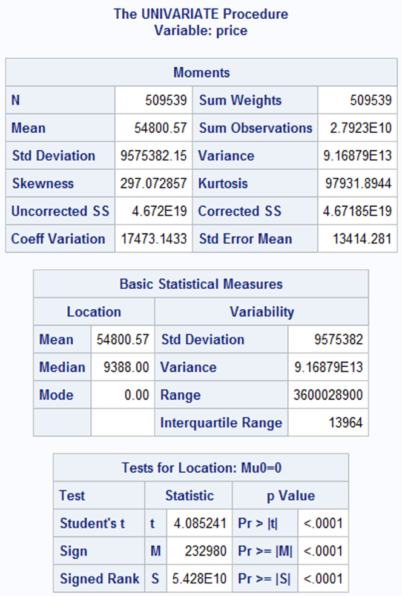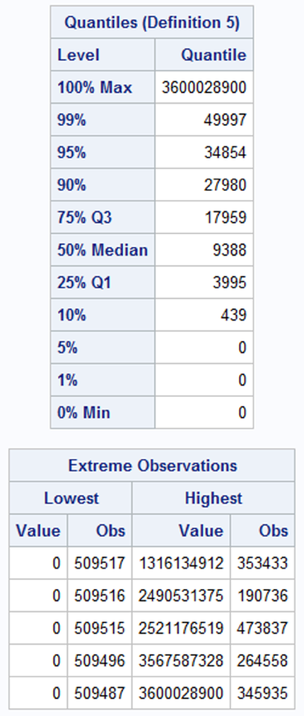

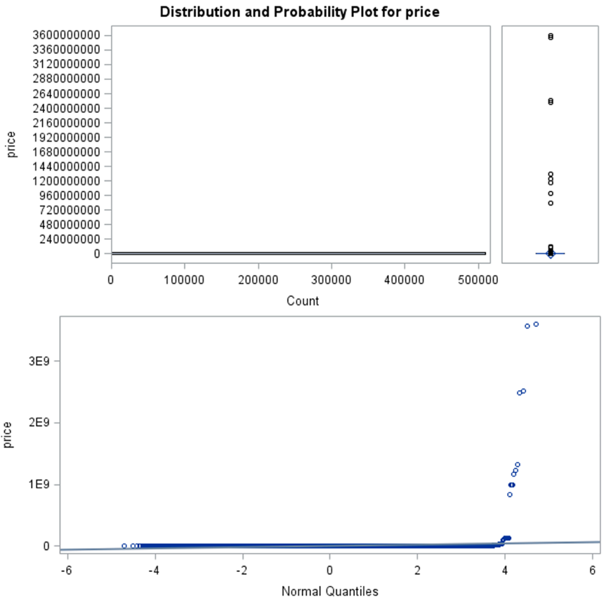

* *Year before cleaning*

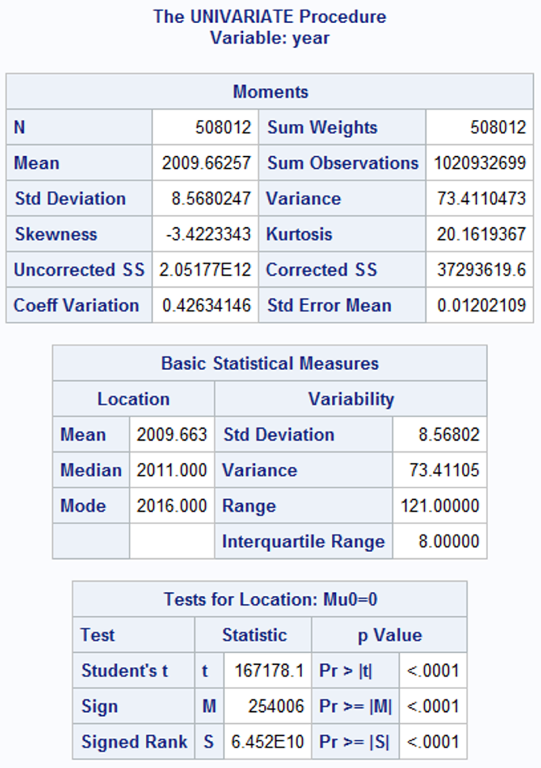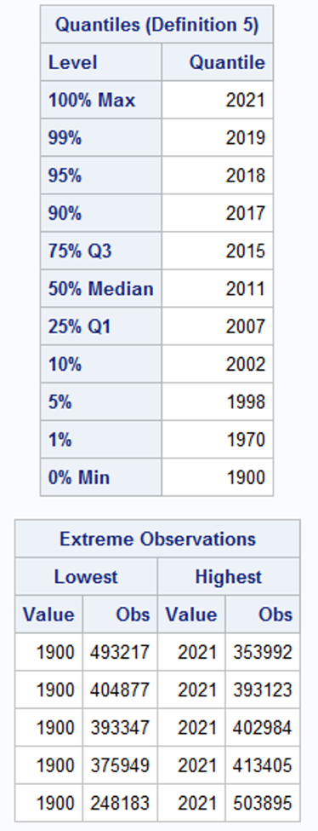

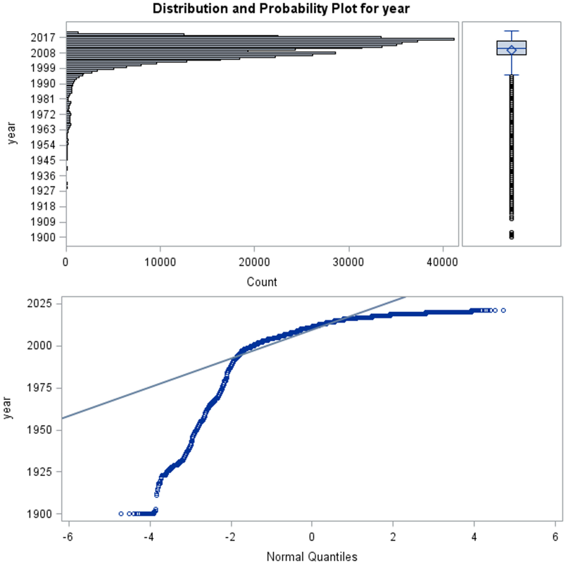

* *Odometer before cleaning*

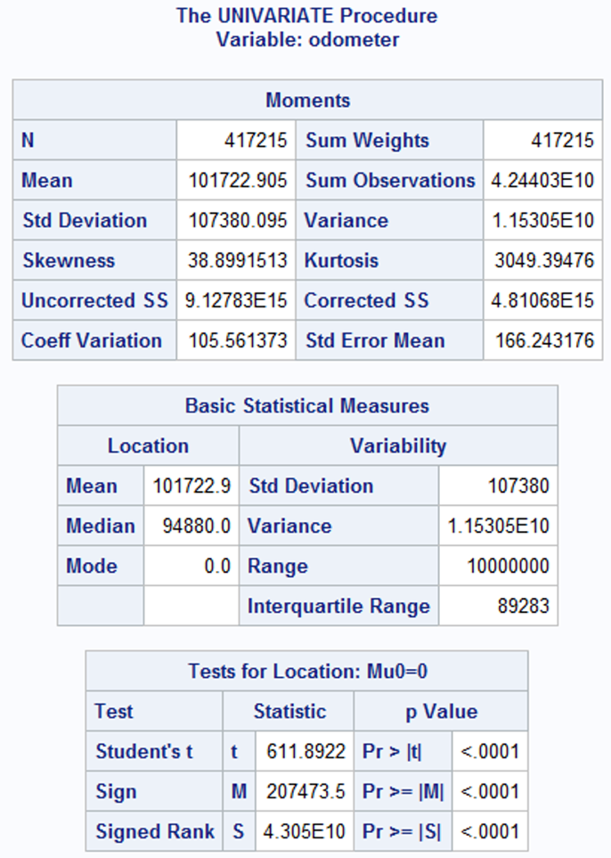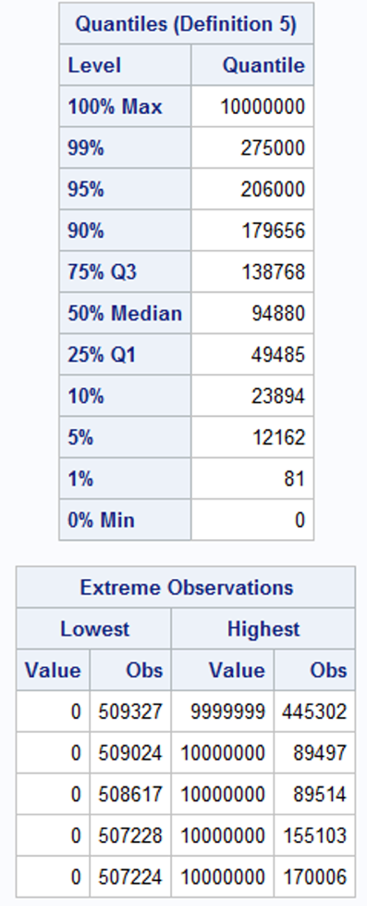

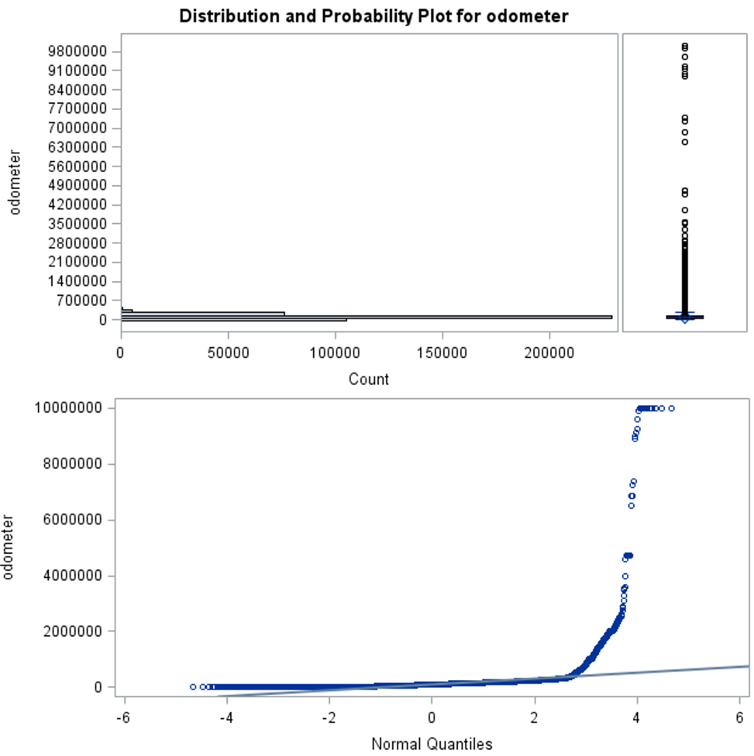

**Figure – 2**

* *Price after cleaning*

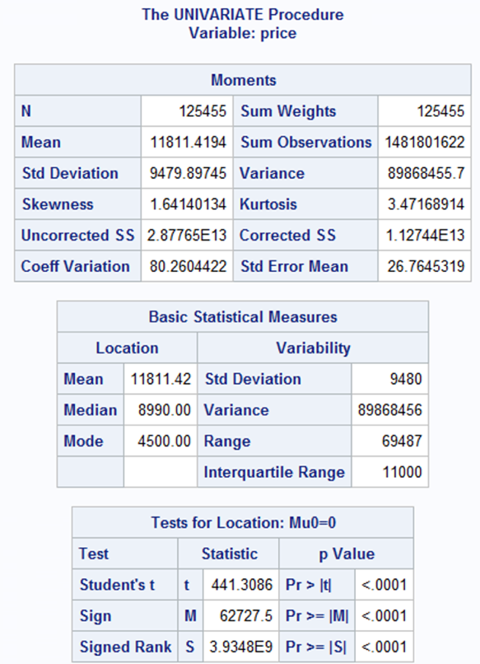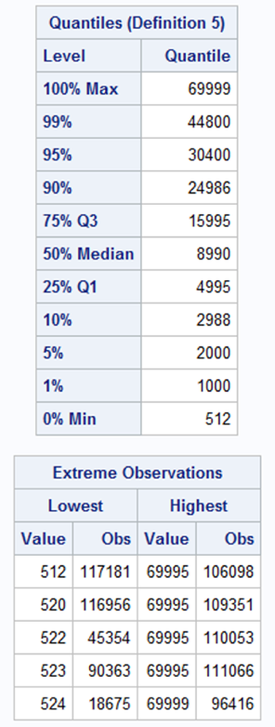

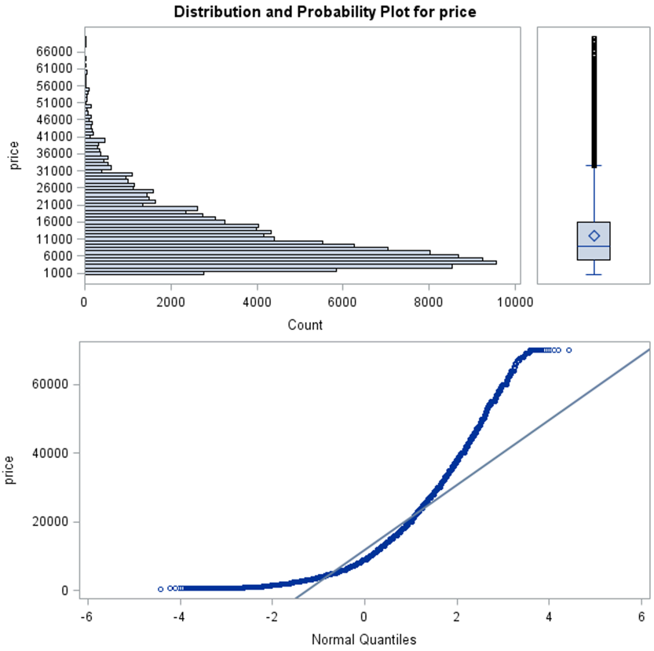

* *Year after cleaning*

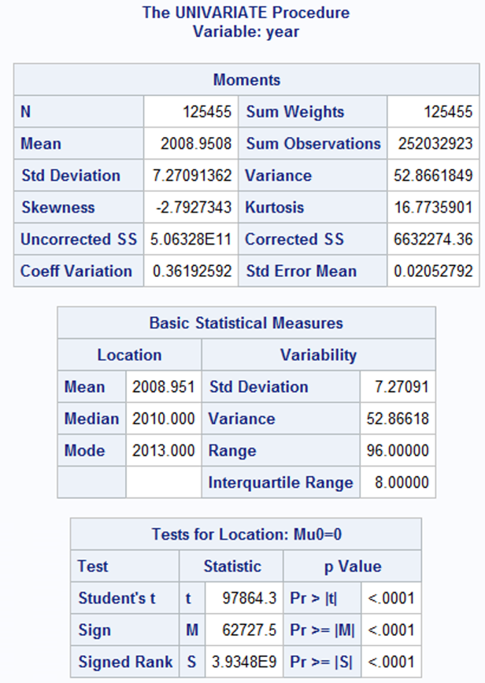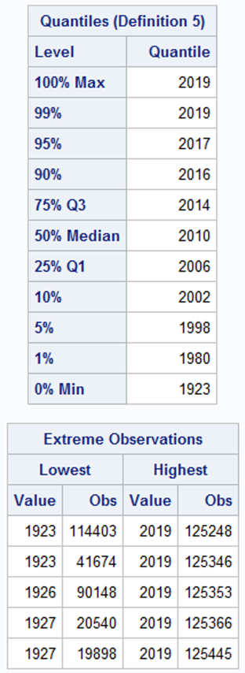

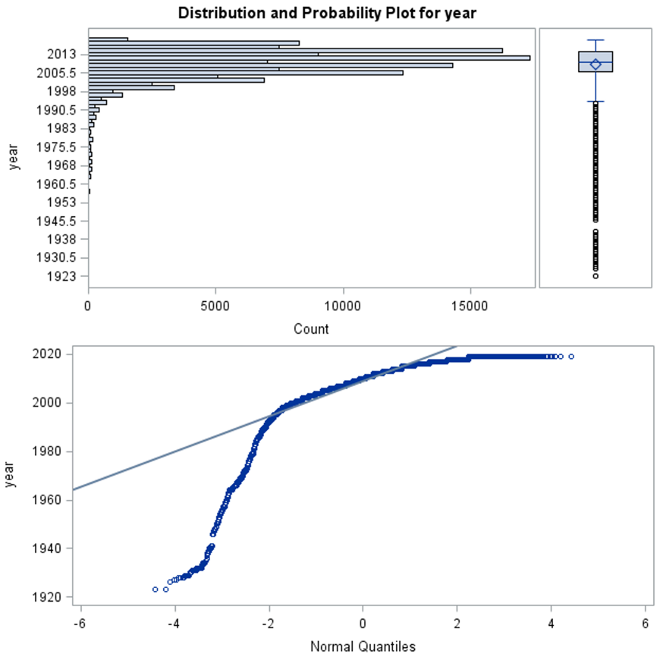

* *Odometer after cleaning*

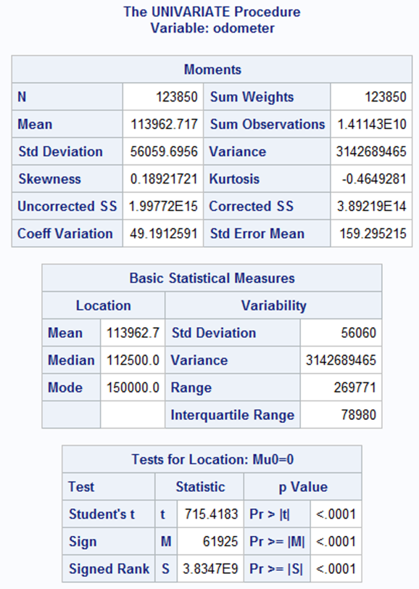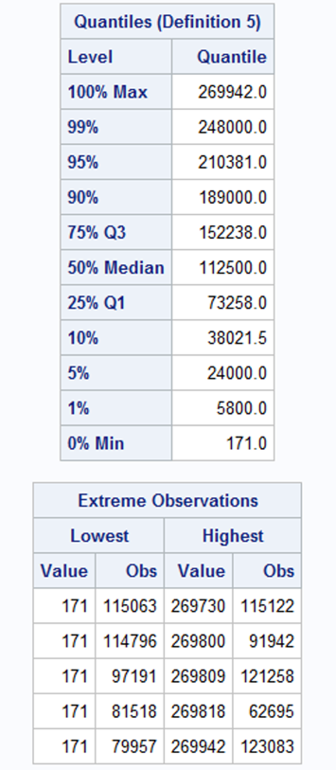

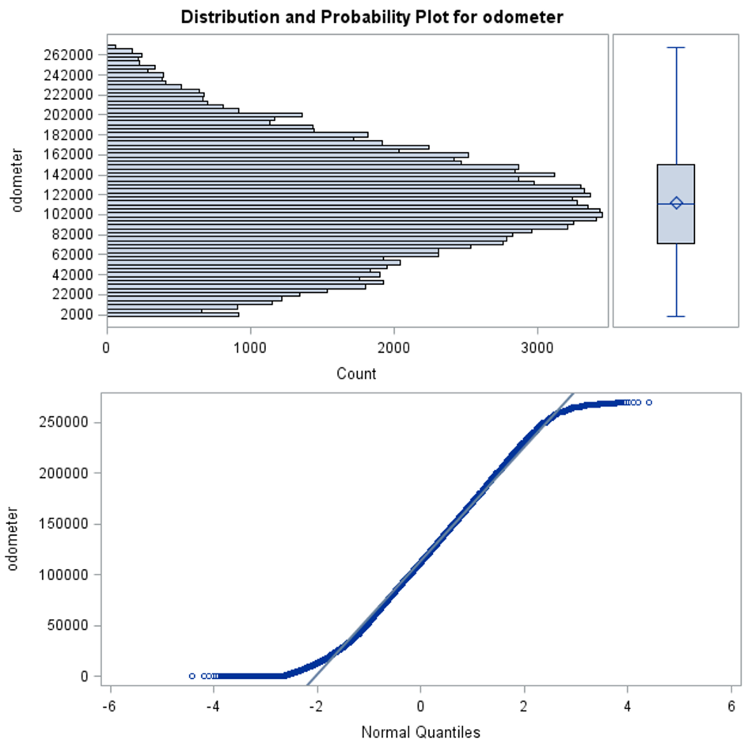

**Figure – 3**

* *Linear Regression data transformation*

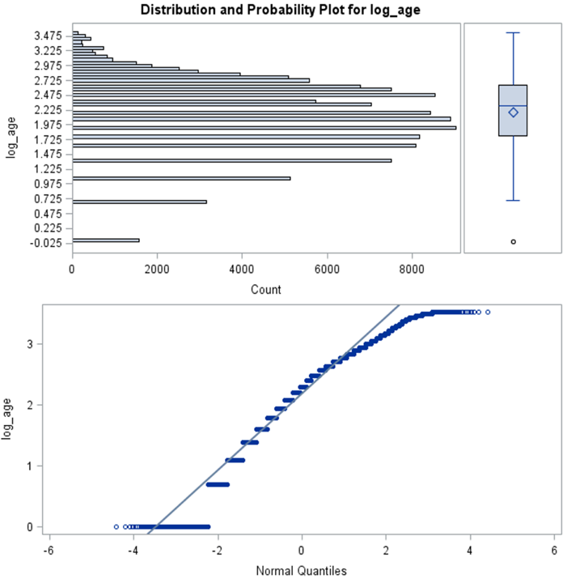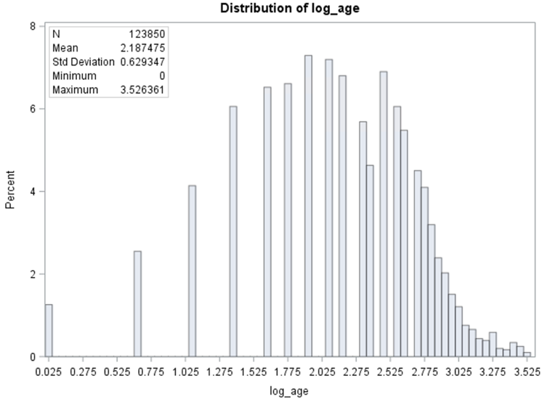

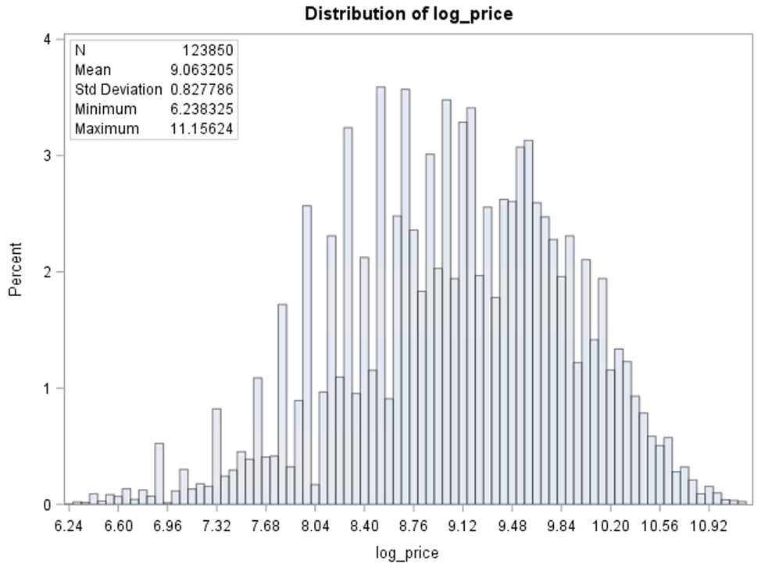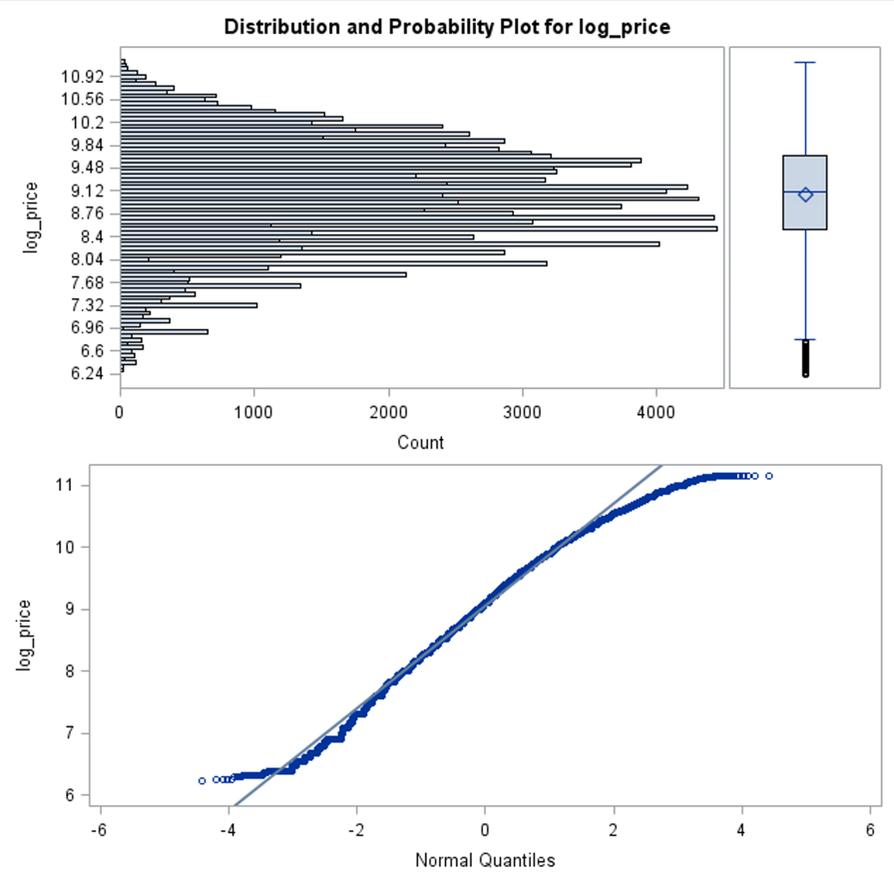

**Figure – 4**

* *Linear Regression Needle plots*

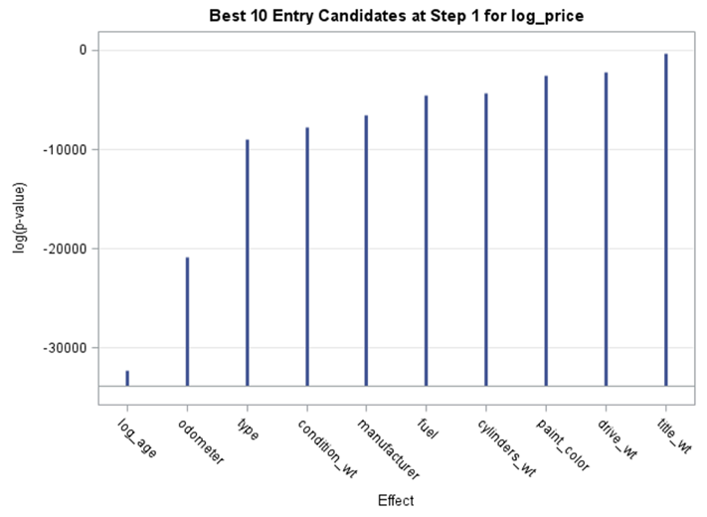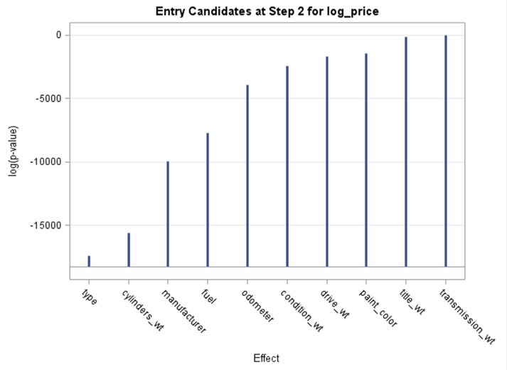

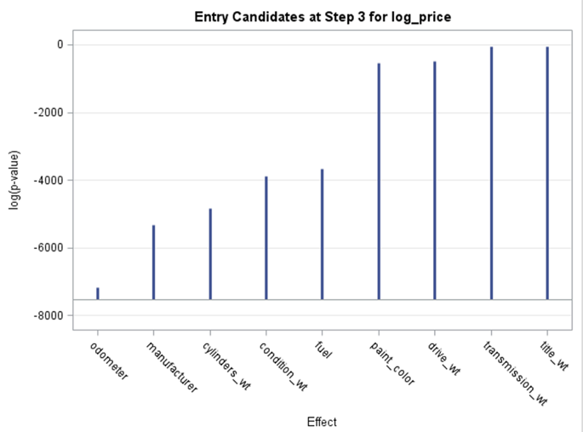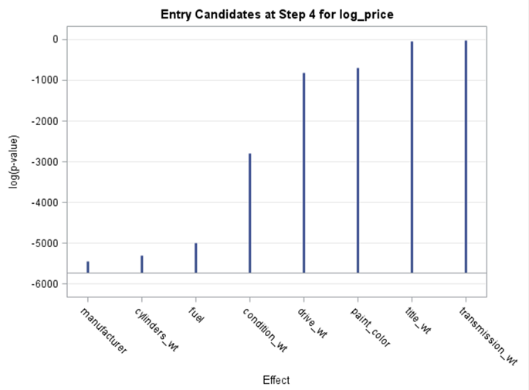

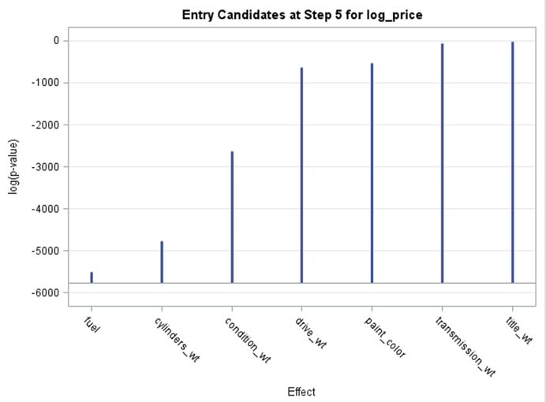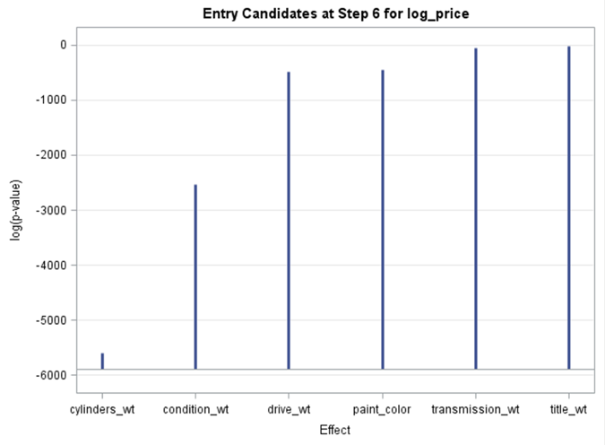

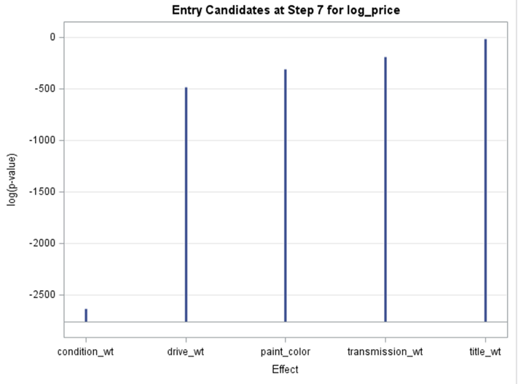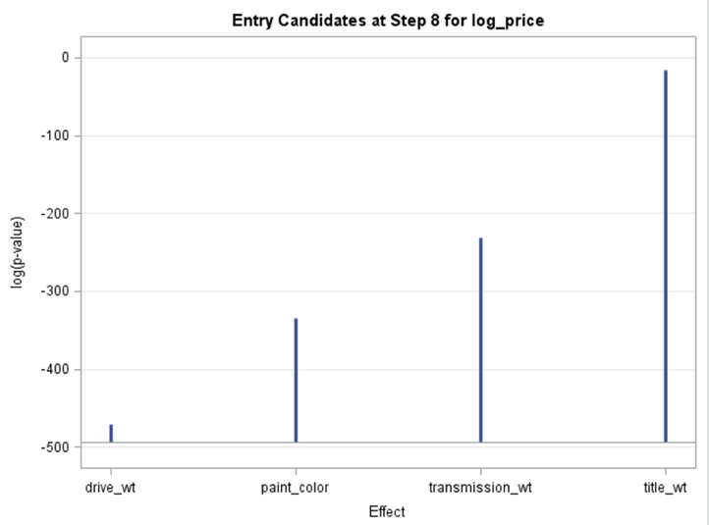

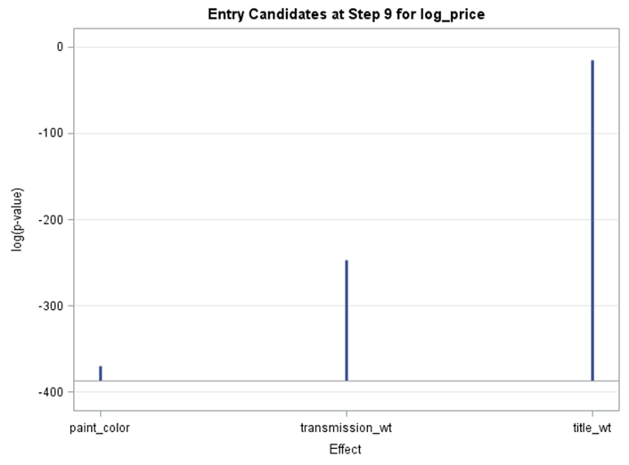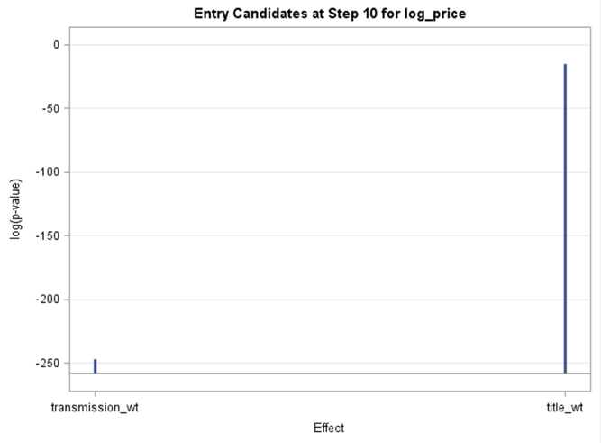

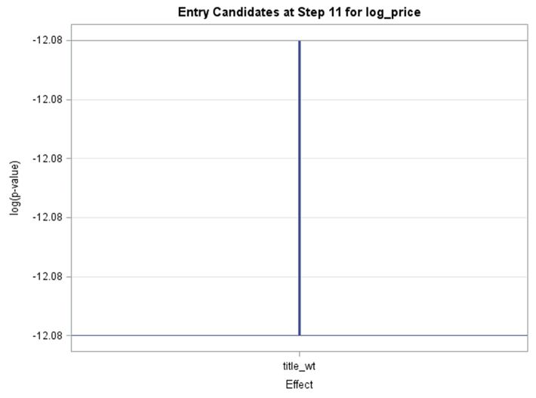

**Figure – 5**

Linear Regression - Selected model features with significance levels

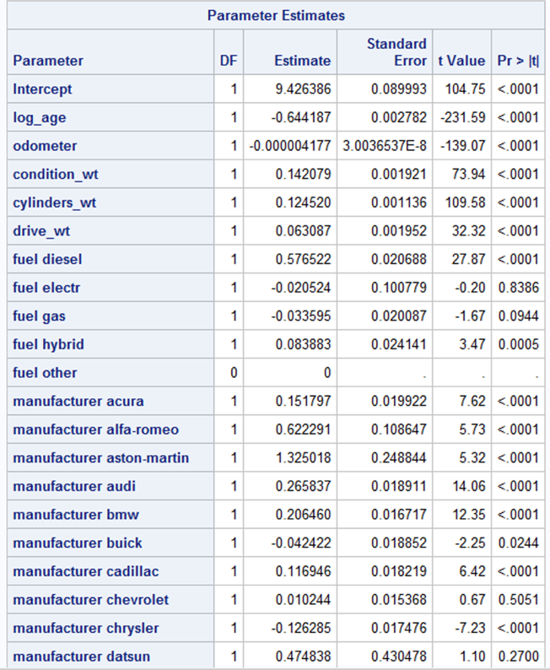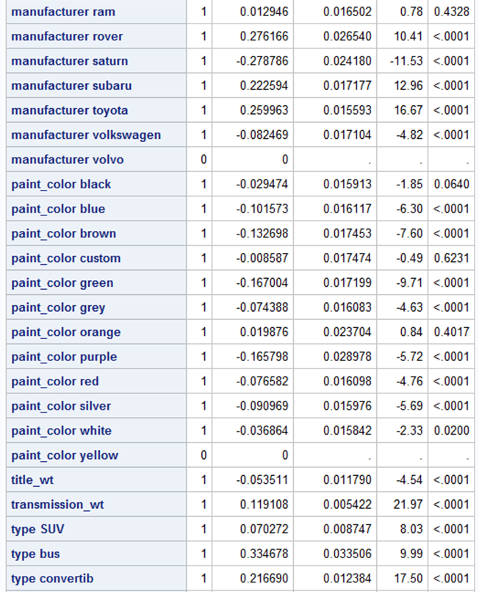

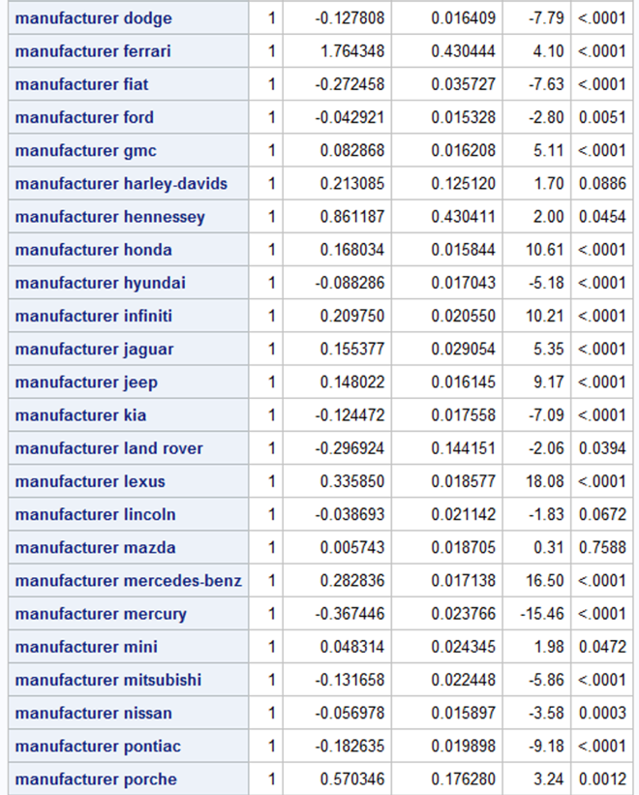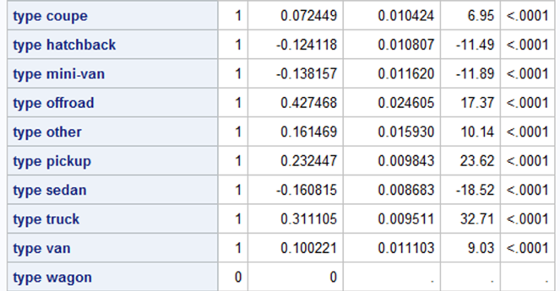

**Figure – 6**

* *Random Forest*

